PRACTICAL – 1(A)

AIM :Program for Convert Decimal into Binary.

Input:

import java.util.*;
import java.io.*;
class dectobin
{
public static void main(String args[]) throws IOException
{
int bin,dec,i=0,n,j;
int[] t = new int[50];
System.out.println("Enter Decimal Number:");
InputStreamReader ir = new InputStreamReader(System.in);
BufferedReader br = new BufferedReader(ir);
String str = br.readLine();
dec = Integer.parseInt(str);
while(dec!=0)
{
n=dec%2;
t[i]=n;
i++;
dec = dec/2;
}
for(j=i-1;j>=0;j--)
{
System.out.print(t[j]);
}
}
}

Output:

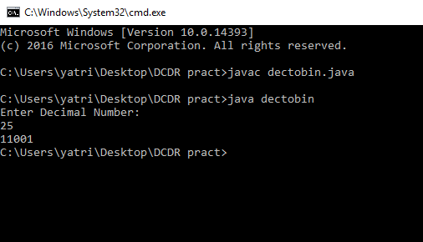

PRACTICAL – 1(B)

AIM :Program for Convert Binary into Decimal.

Input:

import java.util.*;
import java.io.*;
class bintodec
{
public static void main(String args[]) throws IOException
{
int bin,dec=0,i,n,j=1;
System.out.println("Enter binary Number:");
InputStreamReader ir = new InputStreamReader(System.in);
BufferedReader br = new BufferedReader(ir);
String str = br.readLine();
bin = Integer.parseInt(str);
while(bin!=0)
{
n = bin%10;
dec = dec + n*j;
j=j*2;
bin = bin/10;
}
System.out.println("Decimal value is:"+dec);
}
}

Output:

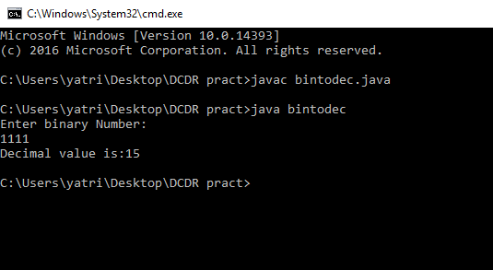

PRACTICAL – 1(C)

AIM :Program for Convert Character into Binary.

Input:

import java.util.*;
import java.io.*;
class chartobin
{
public static void main(String args[]) throws IOException
{
int bin,i=0,n,j;
int[] t = new int[50];
System.out.println("Enter Character:");
InputStreamReader ir = new InputStreamReader(System.in);
BufferedReader br = new BufferedReader(ir);
byte b = (byte)System.in.read();
int dec = (int)b;
System.out.println(dec);
while(dec!=0)
{
n=dec%2;
t[i]=n;
i++;
dec = dec/2;
}
for(j=i-1;j>=0;j--)
{
System.out.print(t[j]);
}
}
}

Output:

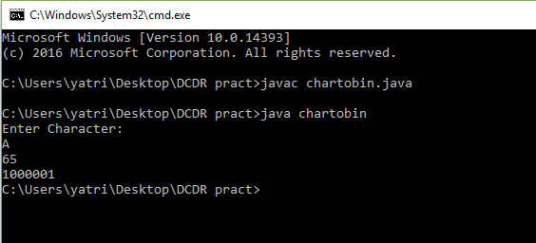

PRACTICAL – 1(D)

AIM :Program for Convert Decimal into Hexadecimal.

Input:

import java.util.*;
import java.io.*;
class dectohex
{
public static void main(String args[]) throws IOException
{
int dec,rem,q,i,j=0;
char[] hex = new char[100];
System.out.println("Enter Decimal Number:");
InputStreamReader ir = new InputStreamReader(System.in);
BufferedReader br = new BufferedReader(ir);
String str = br.readLine();
dec = Integer.parseInt(str);
while(dec!=0)
{
rem = dec%16;
if(rem<10)
{
hex[j++] = (char)(48+rem);
}
else
{
hex[j++] = (char)(55+rem);
}
dec=dec/16;
}
for(i=j;i>=0;i--)
{
System.out.print(hex[i]);
}
}
}
Output:

